Graph Representation
MATH211 : Discrete Mathematics
TA: Ahmed Khaled Sakr

Yuossef hany fathy | Zeyad Mohamed | Karim Mohamed | Kareem sameh ibrahim | Amr said mohammad
241002308 | 241001031 | 241000977 | 231001126 | 241002638

Graph Representation Project

What Are Graphs?
Graphs are mathematical models used to represent relationships between elements. They consist of vertices (nodes) and edges (connections). Graphs are widely used in computer science, mathematics, social networks, and communication systems.

Project Objectives
- Analyze different graph representation techniques
- Understand the advantages and disadvantages of each method
- Represent a sample graph using an adjacency list
- Convert it into an adjacency matrix
- Apply Breadth-First Search (BFS) to explore graph connectivity

Types of Graph Representation
Common graph representations include the adjacency list, adjacency matrix, and edge list. Each representation differs in memory usage, speed, and best use cases.
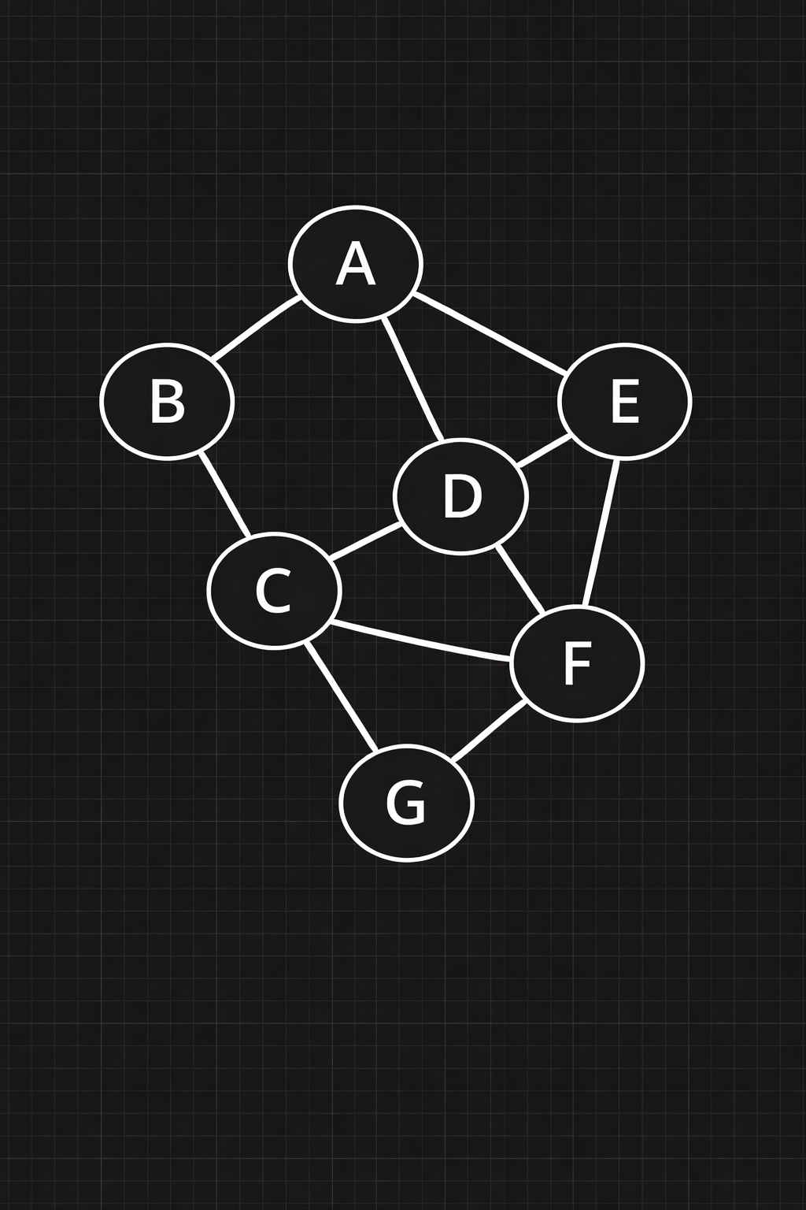

i. BFS Path
BFS Path
A → B → C → F → G

Adjacency List
Pros (Advantages):
- Uses less memory when the graph has few edges.
- Makes it easy and fast to know the neighbors of any vertex.
- Simple to implement using lists or dictionaries.

Cons (Disadvantages):
- Slow when checking if a specific edge exists between two vertices.
- Searching for an edge may take O(n) time in the worst case.
- Not suitable for graphs with a large number of edges.

Node | Edge-1 | Edge-2 | Edge-3 | Edge-4
A | B | D | E | -
B | A | C | - | -
C | B | D | F | G
D | A | C | E | F
E | A | D | F | -
F | C | D | E | G
G | C | F | - | -

ii. Adjacency Matrix
An adjacency matrix is a 2D array where each cell (i, j) is set to 1 if there is an edge from vertex i to vertex j, and 0 otherwise.

- | A | B | C | D | E | F | G
A | 0 | 1 | 0 | 1 | 1 | 0 | 0
B | 1 | 0 | 1 | 0 | 0 | 0 | 0
C | 0 | 1 | 0 | 1 | 0 | 1 | 1
D | 1 | 0 | 1 | 0 | 1 | 1 | 0
E | 1 | 0 | 0 | 1 | 0 | 1 | 0
F | 0 | 0 | 1 | 1 | 1 | 0 | 1
G | 0 | 0 | 1 | 0 | 0 | 1 | 0
Pros:
- Easy to implement and understand.
- Very fast to check if an edge exists between two nodes.
- Good for graphs with many edges.
Cons:
- Requires O(n²) space regardless of the number of edges.
- Inefficient for graphs with few edges (most of the matrix is filled with 0s).
- Iterating over neighbors of a node takes O(n) time even if it has only a few neighbors.

iii. Edge List
An edge list is a simple list or array of all the edges in the graph. Each edge is represented by a pair

No. | Edge
1 | (A, B)
2 | (A, D)
3 | (A, E)
4 | (B, C)
5 | (C, D)
6 | (C, F)
7 | (C, G)
8 | (D, E)
9 | (D, F)
10 | (E, F)
11 | (F, G)

Pros and Cons of Adjacency Matrix
- Pros:
Very easy to implement and understand.
Simple structure that is easy to store and read.
- Cons:
Checking connectivity between vertices can be slow.
Not efficient for many graph algorithms.

Comparison Table
Feature | Adjacency List | Adjacency Matrix | Edge List
Memory Usage | Efficient for sparse graphs | Inefficient for sparse graphs | Most efficient
Edge Traversal | Slow | Fast | Slow
Neighbor Traversal | Fast | Slower | Full scan required
Best Use Case | Sparse graphs | Dense graphs | Simple sparse graphs
Implementation | Moderate | Easy | Easy

Applications of Graph Representations

Adjacency List
Adjacency lists are ideal for sparse graphs. They store only existing connections, making them memory-efficient and suitable for social networks, navigation systems, and web crawling applications.

Adjacency Matrix
Adjacency matrices are best suited for dense graphs where fast edge lookup is required. They are commonly used in communication networks, image processing, and game development.

Edge List
Edge lists store only the edges of a graph. They are useful for importing/exporting data and applications where edges are processed sequentially.

Conclusion
In this project, we explored multiple graph representations and concluded that the adjacency list is the most suitable for our graph due to its sparsity and efficiency. The project enhanced our understanding of BFS and emphasized the importance of choosing the appropriate representation based on the problem requirements.
FOR PYTHON :

from collections import deque
# Graph representation based on the given diagram
graph = {
'A': ['B', 'D', 'E'],
'B': ['A', 'C'],
'C': ['B', 'D', 'F', 'G'],
'D': ['A', 'C', 'E', 'F'],
'E': ['A', 'D', 'F'],
'F': ['C', 'D', 'E', 'G'],
'G': ['C', 'F']
}
vertices = sorted(graph.keys())
def adjacency_matrix(graph):
n = len(vertices)
matrix = [[0]*n for _ in range(n)]
index = {v: i for i, v in enumerate(vertices)}
for v, neighbors in graph.items():
for neigh in neighbors:
matrix[index[v]][index[neigh]] = 1
return matrix
def bfs(graph, start, goal):
queue = deque([start])
visited = {start}
parent = {start: None}
while queue:
node = queue.popleft()
if node == goal:
break
for neigh in graph[node]:
if neigh not in visited:
visited.add(neigh)
parent[neigh] = node
queue.append(neigh)
path = []
curr = goal
while curr is not None:
path.append(curr)
curr = parent.get(curr)
path.reverse()
return path if path and path[0] == start else None
if __name__ == "__main__":
matrix = adjacency_matrix(graph)
print("Vertices:", vertices)
print("\nAdjacency List:")
for v in vertices:
print(f"{v}: {graph[v]}")
print("\nAdjacency Matrix:")
print(" " + " ".join(vertices))
for i, v in enumerate(vertices):
print(v, " ".join(str(x) for x in matrix[i]))
start, goal = 'A', 'G'
path = bfs(graph, start, goal)
print("\nShortest BFS path:", " -> ".join(path))

References:---
Rosen, Kenneth H. Discrete Mathematics and Its Applications. 7th Edition. McGraw-Hill Education, 2012. (Chapter 10 - Graphs)

Discrete Math - 10.1.1 Introduction to Graphs https://www.youtube.com/watch?v=QHmL0AnZ3Dc

Breadth-first search in 4 minutes

https://www.youtube.com/watch?v=HZ5YTanv5QE

